|  |
| --- |
| **SOEN 6481**  **Software Systems Requirements Specification**  **Summer 2015**  Deliverable 2  Ticket Vending Machine used in Societe de Transport de Montreal  Team - D  Dharani Kumar Palani  Dhruv Ohri  Naresh Kumar  Shu Liu  Xiaodong Li  Yang Liu |



Table of Contents

**1.** **Introduction** 3

**2.** **Domain Model** 3

**2.1** **Domain Model Diagram** 3

**2.2** **Domain Model Description** 4

**2.3** **Relationships** 5

3. Use Case Model 7

4. Team Member-Responsibility Table 8

5. Tools Used for Deliverable 1 9

6. References 10

# **Introduction**

Domain Model is a way to describe and model real work entities and the relationships between them which assists in solving a problem. It represents the entities or the events that are known in the business environment and creates a common vocabulary for communication among team members. It gives you a conceptual framework of the things in the problem space and helps you to focus on semantics. It takes into account system's classes, their attributes, operations (or methods) and the relationships among them.

# **Domain Model**

# **Domain Model Diagram**

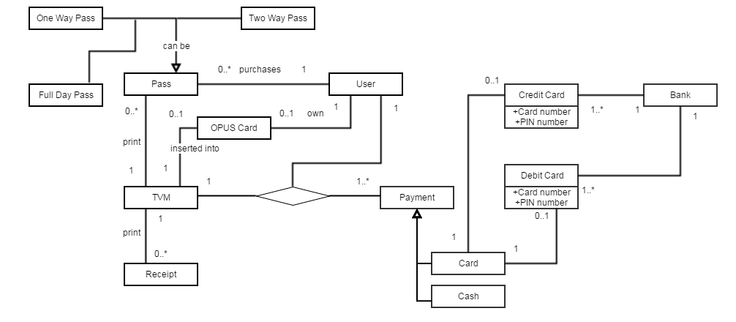

# **Domain Model Description**

**Table 1: List of all Concept Classes and their Description**

|  |  |
| --- | --- |
| **Concept**  **(Class Name)** | **Description** |
| User | Represents a person with a OPUS card or he/she can buy a ticket |
| OPUS Card | Represents STM OPUS Card which is only charged after being inserted in TVM and then paid with a particular amount to charge it |
| Pass | Represents different kinds of passes, it can either be one way, two way or full day |
| Payment | Represents different kinds of payment for transaction which can either be Cash, Debit Card or Credit Card |
| Debit | Represents use of a Debit Card to pay the price of OPUS Card or of the passes with correct card number and pin number |
| Credit | Represents use of a Credit Card to pay the price of OPUS Card or of the passes with correct card number and pin number |
| Cash | Represents use of cash for payment without interacting with the bank |
| TVM | Represents interaction with User for buying a pass or user interacts to charge his/her OPUS Card and after completing the transaction prints a receipt |
| Receipt | Represents printing of receipt after the transaction is properly completed |
| Card | Represents method of payment when using Card either can be Debit Card or Credit Card |
| Bank | Represents banking verification when the payment by a card is selected, verifies the card by card number, pin number and expiry date of the card being used. |

# **Relationships**

The relationships between classes are need to be defined. Multiplicity describes how many instances of one class can be associated with one instance of the related class.

Some of the multiplicity symbols, we used in our DM.

1 = Exactly one;

0..1 = Zero or one;

0..*= Zero or many;

1..*= One or many;

* = Many;

**Table 2: List of all Concept Classes and their Relationships**

|  |  |  |  |
| --- | --- | --- | --- |
| **Source Concept** | **Target Concept** | **Relationship** | **Description** |
| User | TVM | Association | User can use TVM to buy the passes or charge his OPUS Card |
| User | Payment | Association | User makes several payment for the pass(s) or OPUS Card by Cash or Card |
| User | Pass | Association | User can buy several pass(s) to travel |
| User | OPUS Card | Association | User can own one OPUS Card or he/she does not have OPUS Card |
| TVM | Pass | Association | One TVM can print several Passes as per User desired request. It is possible that TVM does not print any Passes. |
| TVM | Payment | Association | TVM can process several payment. |
| TVM | Receipt | Association | TVM after completing the tasks of pass(s) or OPUS Card prints several receipt |
| TVM | OPUS Card | Association | Opus Card is inserted into TVM to get charged |
| Payment | Card | Inheritance | Paying by Card is one way to make payment. It can either be Credit Card or Debit Card |
| Payment | Cash | Inheritance | Payment can also be paid by Cash |
| Card | Credit Card | Association | Card can be Credit Card, which can be verified by proper Card Number and PIN Number |
| Card | Debit Card | Association | Card can be Debit Card, which can be verified by proper Card Number and PIN Number |
| Credit Card | Bank | Association | Every Credit Card belongs to one Bank so needs to verified in order to complete the transaction |
| Debit Card | Bank | Association | Every Credit Card belongs to one Bank so needs to verified in order to complete the transaction |

# Use Case Model

# Team Member-Responsibility Table

|  |  |
| --- | --- |
| **Team Member** | **Details of Responsibilities** |
| Dharani Kumar Palani |  |
| Dhruv Ohri |  |
| Naresh Kumar | Management of Team, dividing of Tasks equally among all team members, Domain Modelling, Domain Model Description and the relationships(P1) |
| Shu Liu | Domain Modelling, Domain Model Description and the relationships(P1) |
| Xiaodong Li |  |
| Yang Liu |  |

P1: Problem 1

P2: Problem 2

Link to the project wiki homepage:

[https://srs-soen-6481-d.wikispaces.com/home](https://soen6481fall14b.wikispaces.com/home)

# Tools Used for Deliverable 1

Following are the tools we used for your communication, creating documents, generating diagrams for different tasks:

* Wikispaces
* Whatsapp
* Yahoo Mail
* TeamViewer
* Gliffy

We have used the course materials, notes, important links presented during the lectures and the meeting minutes with Teaching Assistant to complete the required tasks for Deliverable 2.

# References

1. P. KAMTHAN, “INTRODUCTION TO DOMAIN MODELING”, SOEN 6481, Department of Computer Science and Software Engineering, Concordia University, summer, 2015.
2. P. KAMTHAN, “IMPLICATIONS OF SOFTWARE ENGINEERING PRINCIPLES FOR DOMAIN MODELING”, SOEN 6481, Department of Computer Science and Software Engineering, Concordia University, summer, 2015.
3. P. KAMTHAN, “INTRODUCTION TO USE CASE MODELING”, class notes for SOEN 6481, Department of Computer Science and Software Engineering, Concordia University, summer, 2015.